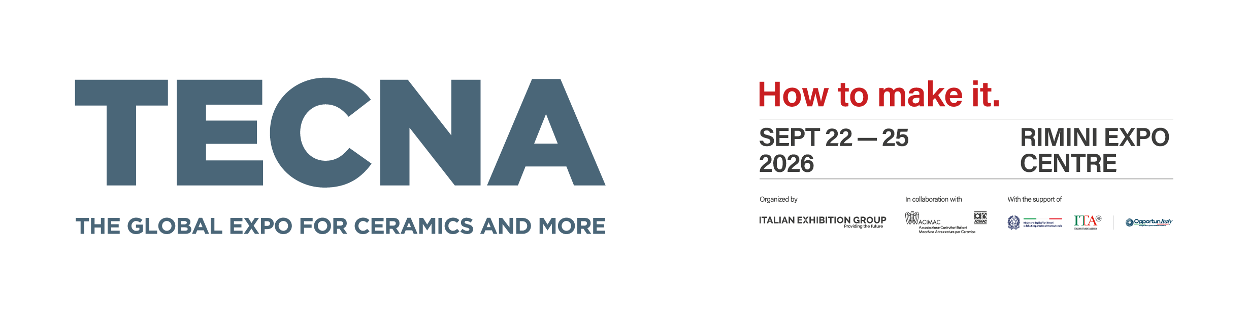
Press Release
Tecna 2026: a programme of events exploring the future of surfaces
The 29th edition of the Global Expo for ceramics and more returns to Rimini from 22 to 25 September with a completely new programme of conferences, seminars and awards
(Rimini, May 15, 2026) – Tecna, the Global Expo for ceramics and more, returns to Rimini from 22 to 25 September 2026 for its 29th edition. The show will welcome the leading players in the surfaces industry with a packed programme of events, including technical conferences, panel discussions, seminars and a completely redesigned format for the TECNAwards. The programme confirms Tecna’s role as not just a technological showcase but a platform for sharing knowledge and a strategic vision for the entire supply chain.
The exhibition is organised by Italian Exhibition Group (IEG) in collaboration with Acimac (Italian Ceramic Machinery and Equipment Manufacturers’ Association).
TECNAwards: a completely new format
The programme opens with the TECNAwards, the international recognition that Tecna bestows on the most significant technological investments made by exhibitors’ customers. For 2026, the format has been completely reimagined with a more extensive and detailed schedule extending over two days, Tuesday 22 and Wednesday 23 September.
The first day will coincide with the exhibition’s inaugural conference; the awards will focus on the Americas, specifically the Mercosur Agreement, alongside panel discussions on the geopolitical scenarios reshaping the industry. On the second day, the focus will shift to Europe and Asia, where demand for technology continues to grow.
By celebrating excellence in a sector that continues to invest in innovation, the awards play an essential role in cementing Tecna’s status as a bridge between technology suppliers and ceramic manufacturers.
Technical conferences and new events
The technical conference programme will run for the entire duration of the exhibition, with sessions dedicated to key issues for the sector. Wednesday 23 September will begin with a conference on raw materials, addressing supply chain challenges and strategies to secure supply and competitiveness. Over the following days, the schedule will continue with sessions on intralogistics, digitalisation and new production models (Macchine X), as well as a presentation of the European Ceramics Hub project, developed in collaboration with Portugal and Spain. As part of its growing focus on high-performance industrial applications, Tecna will also participate in a conference on advanced ceramics hosted at BEX - Beyond Exploration Expo, the co-located exhibition dedicated to the Space Economy.

Decortech Conference: two days dedicated to the future of surfaces
The Decortech Conference dedicated to innovations in surface decoration and finishing is also returning this year, with a programme curated for the first time by a Technical Committee consisting of leading associations, professionals and companies. The two-day event – scheduled for Wednesday 23 and Thursday 24 September in the Decortech Arena – will bring together key opinion leaders, including architectural firms, industry experts, technology providers, leading international buyers, universities and training institutions.
This shift reflects Decortech’s ambition to become an international benchmark for the world of surface technology, aesthetics and design, adopting a cross-sector industrial approach rather than a traditional, material-based focus.
At the heart of Surfaces Week
Tecna 2026 is part of Surfaces Week, the most important event on the industry calendar, alongside other leading exhibitions such as Cersaie and Marmomac. It offers a unique opportunity for professionals and international buyers to explore the entire production chain in the space of just a few days and at the same exhibition centre.
The full schedule of events will be announced in the coming weeks.

FOCUS ON ITALIAN EXHIBITION GROUP
Italian Exhibition Group S.p.A., a joint stock company listed on Euronext Milan, a regulated market organised and managed by Borsa Italiana S.p.A., has built up a domestic leadership position in the organisation of trade fairs and congresses over the years with facilities in Rimini and Vicenza. Its international activities, conducted partly through joint ventures with global or local organisers in the United States, United Arab Emirates, Saudi Arabia, China, Mexico, Germany, Singapore and Brazil, have established it as one of the leading European players in the sector.
FOCUS ON ACIMAC
ACIMAC is the association of Italian manufacturers of plant, machinery, equipment and semi-finished products and suppliers of raw materials and services for the ceramic (tile, sanitaryware and tableware), heavy clay and refractory materials industries. ACIMAC represents the majority of Italian companies in the sector, from small and medium sized businesses through to the largest firms. ACIMAC is affiliated to the Italian employers’ federation Confindustria, making it an integral part of Italian industry’s system of representation.

To stay up to date, visit www.tecnaexpo.com

