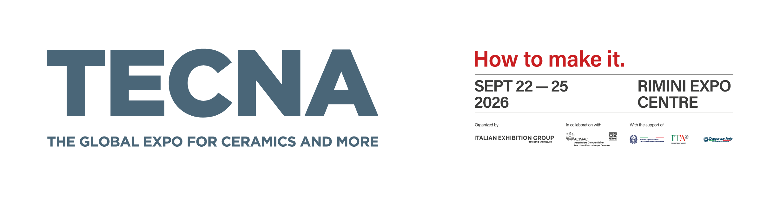
Press release
TECNA 2026: Colour returns to the global surfaces exhibition
The 29th edition of TECNA – The Global Expo for ceramics and more will take place at the Rimini Expo Centre from 22 to 25 September 2026. Major new features include the return of glaze and colour producers and chemical additive manufacturers, alongside a completely redesigned Decortech Conference.
Rimini, 23 June 2026 – From 22 to 25 September 2026, the Rimini Expo Centre will host the 29th edition of TECNA – The Global Expo for ceramics and more, organised by IEG – Italian Exhibition Group in collaboration with ACIMAC. A global benchmark for technology, machinery, aesthetics and design in the ceramic and heavy clay industries for over forty years, TECNA will return in 2026 with an even more comprehensive exhibition offering.
The return of glaze and colour producers and chemical additive manufacturers
One of the most significant developments at this edition of TECNA is the return of glaze and colour producers and chemical additive manufacturers, a clear signal of the entire supply chain’s desire to join forces and work as a system. Leading names in the sector have already confirmed their participation.
Ceramicolor-Federchimica, the Italian association of ceramic glaze and colour producers and metal oxide manufacturers, will not only sit on the Technical Committee for the Decortech Conference but will also have a 100-square-metre stand where visitors will be able to discover the latest industry innovations first hand.
As the association’s Chairman Pierluigi Ghirelli noted: “TECNA 2026 is a very important event for Ceramicolor because it brings together expertise, technologies and visions that contribute to the evolution of the entire ceramic supply chain. As an association, our role is to promote the wealth of knowledge of our member companies, foster dialogue between the various players in the industry and support the growth of a sector whose most distinctive strengths include colour, research and the quality of Made in Italy. Our participation in the exhibition will provide an opportunity for us to reaffirm the importance of working as a system, from training new generations and enhancing the district’s expertise to fostering collaboration between companies, institutions and the research world. It is through this shared path that Ceramicolor intends to contribute to the future of the Italian ceramic industry, strengthening its identity, competitiveness and capacity for innovation in international markets.”
Simone Tassi, Ceramic Division Director at Lamberti Group, emphasised the importance of dialogue across the supply chain. “TECNA represents a vital opportunity for Lamberti to engage with the entire international ceramic supply chain. In a constantly evolving scenario, we believe that true value comes from the ability to connect innovation, proximity and expertise in order to respond effectively to emerging market demands. In Rimini, we will be presenting CORE, our vision of Smart Chemistry: a range of highly concentrated products and solutions designed to simplify processes, optimise logistics and generate value throughout the ceramic supply chain. Thanks to advanced formulations and a network of manufacturing hubs in all the major ceramic districts, we concentrate our expertise where it creates the greatest value: with our customers, their processes and their applications. Because we believe the future of ceramics will be built by focusing value where it matters most.”
Smaltochimica has also announced that it will be back this year. “Smaltochimica’s return to TECNA 2026 stems from the conviction that today, more than ever, we need to work together and support the entire ceramic supply chain,” explained Dr Chiara Piccinini, Owner and Head of Marketing & Communications at Smaltochimica S.r.l. “From manufacturing technologies and additives to glaze and colour producers, graphic design studios and tile manufacturers, every link in the chain contributes to the sector’s growth, innovation and competitiveness. TECNA represents an important opportunity to enhance these synergies, foster dialogue between companies and underline the fact that future challenges can only be addressed through collaboration, shared expertise and a common vision. This is why we have chosen to participate and contribute to a strategic event for the entire sector.”
Altadia Group has also chosen to take part in TECNA and will be present in Rimini with a 100 square metre stand entirely dedicated to innovation and managed by its Innovation Team, the multidisciplinary group responsible for all of Altadia’s new research projects. “TECNA is the ideal showcase for discussing technological innovation in the ceramic sector,” explained Alessandro Ferrari, CEO of Altadia Italia and Chief Innovation & Technology Officer at Altadia. “For this reason, we will be presenting a spin-off of our new Global Innovation Hub, the centre where all technological Research and Development for the Altadia Group worldwide will be concentrated and which is due to be inaugurated in Sassuolo during the same period.”
Zschimmer & Schwarz – Z&S Ceramco is another major name that will be back at TECNA. “Returning to TECNA is a natural and carefully considered choice for Zschimmer & Schwarz,” said Pierluigi Ghirelli, Managing Director of Z&S Ceramco. “Although we have continued to work closely with the ceramic supply chain, in recent years we have chosen to focus on other industry events. Today, we feel the time is right to return to TECNA, to engage with the industry and present our company and our latest innovations.”
The participation of glaze and colour producers and chemical additive manufacturers underscores TECNA 2026’s role as a strategic meeting point for the entire surfaces supply chain, enriching the exhibition and conference programme built around the Decortech Conference, a two-day event dedicated to materials, aesthetics, technology, trends and design.

FOCUS ON ITALIAN EXHIBITION GROUP
Italian Exhibition Group S.p.A., a joint-stock company listed on Euronext Milan, a regulated market organised and managed by Borsa Italiana S.p.A., has established itself over the years as a leading organiser of trade fairs and conferences in Italy through its Rimini and Vicenza venues. It has also expanded its international activities, including through joint ventures with global and local organisers in countries such as the United States, the United Arab Emirates, China, Mexico, Germany, Singapore and Brazil, positioning itself among Europe’s leading operators in the sector.
FOCUS ON ACIMAC
Acimac is the association of Italian manufacturers of plant, machinery, equipment, semi-finished products, raw materials and services for the ceramic industry (tiles, sanitaryware and tableware), as well as the heavy clay and refractory materials industries. Acimac represents the majority of Italian companies in the sector, from small and medium-sized enterprises to larger corporations. As a member of Confindustria, Acimac forms part of the main representation system for Italian industry.

To stay up to date, visit www.tecnaexpo.com

