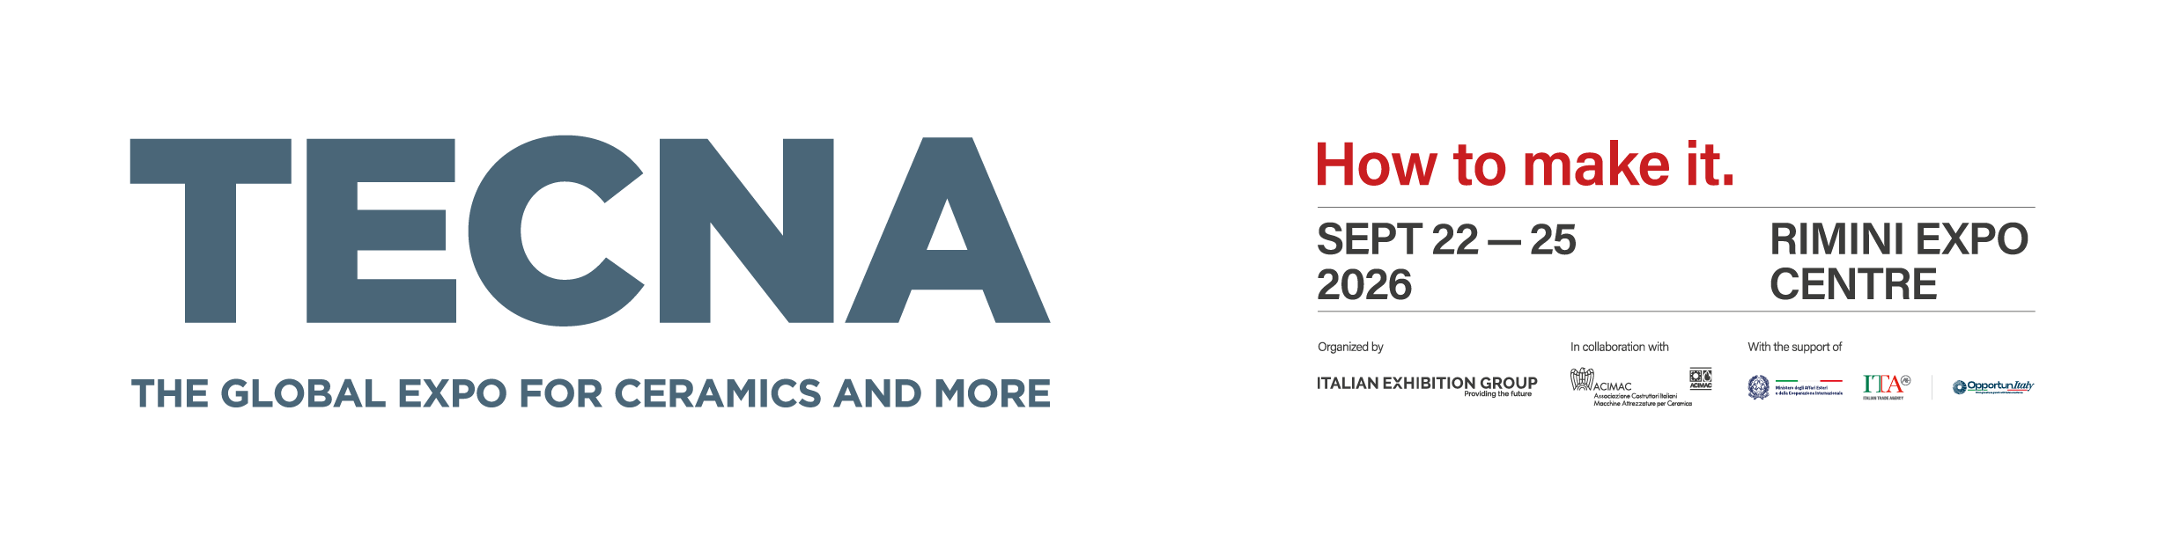
Press Release
TECNA 2026: more than 250 buyers from all over the world along with a growing number of international visitors
Three weeks before it is due to open, the 29th edition of “The Global Expo for Ceramics and more” is reporting twice as many selected international buyers as the previous edition, along with growing numbers of visitor pre-registrations and a strong overseas presence.
Rimini, 4 September 2026 – TECNA – The Global Expo for Ceramics and more will open in the Rimini Expo Centre in less than three weeks, running from 22 to 25 September 2026. Early figures point to an edition with a particularly strong international visitor presence. The 29th edition of the show, organised by IEG – Italian Exhibition Group in partnership with ACIMAC, reaffirms TECNA’s position as a global reference point for technologies, plant, aesthetics and design for the ceramic and heavy clay industries, attracting qualified industry professionals from all over the world.
The clearest sign of TECNA’s growing international reach comes from its buyer programme, a free service that enables exhibitors to meet international purchasing decision-makers at the event. While the previous edition brought 110 selected international professionals to Rimini, the ambitious goal for 2026 was to double that figure. Thanks to close collaboration with the Italian Trade Agency (ITA), this target has been exceeded and more than 250 international buyers representing 44 countries are expected to attend.
The buyer programme is accompanied by a dedicated digital platform for exhibitors, which allows them to view buyer profiles and request B2B meetings. More than 900 meeting requests were submitted within the first few hours of its launch on 26 August, a clear sign of strong mutual interest between buyers and suppliers. In addition, 32 ceramic producer associations from around the world have confirmed their participation at the event.
The significance of these figures goes beyond sheer numbers. Buyers come from a remarkably broad range of markets, with particularly strong participation from several key regions. North Africa, Central and South Asia – especially India – and Latin America together account for more than half of the selected buyers. Latin America is one of the most dynamic and best represented regions, prompting a specific focus on Mercosur at this year’s show. The region is currently one of the markets attracting the greatest interest from the surfaces industry and Italian technology suppliers.
This attention is also reflected in the event programme. The first day of the TECNAwards on 22 September will be dedicated to the Americas, with an in-depth look at the Mercosur Agreement and the geopolitical developments reshaping the sector. On 23 September, the focus will broaden to Europe, Asia and Africa.
“The presence of twice as many international buyers as at previous editions and the wide range of regions represented send a clear message: interest in technological innovation is extremely high worldwide, and Italy continues to be seen as a key reference point,” comments Gian Paolo Crasta, Director of ACIMAC. “This interest spans Asia, Africa, the Middle East and Latin America, with Mercosur receiving particular attention at this edition. TECNA is once again fulfilling its role as the place where the global surfaces supply chain comes together to exchange ideas and gain an early sense of where the industry is heading.”
Visitor pre-registration figures are equally encouraging. As of 28 August 2026, visitor pre-registrations were 10% higher than at the same stage before the previous edition, with around half coming from overseas. These international pre-registrations span 85 countries across Europe, the Mediterranean region, North Africa, the Middle East, South and Southeast Asia and the Americas.
Three weeks before opening, these figures point to a strong edition and confirm TECNA’s ability to attract international buyers seeking new technology.
Overall, these positive indicators reinforce TECNA 2026’s position as one of the sector’s leading international events, not just as a technology showcase but also as a platform for business, knowledge sharing and strategic insight across the entire surfaces supply chain.

FOCUS ON ITALIAN EXHIBITION GROUP
Italian Exhibition Group S.p.A., a joint-stock company listed on Euronext Milan, a regulated market organised and managed by Borsa Italiana S.p.A., has established itself over the years as a leading organiser of trade fairs and conferences in Italy through its Rimini and Vicenza venues. It has also expanded its international activities, including through joint ventures with global and local organisers in countries such as the United States, the United Arab Emirates, China, Mexico, Germany, Singapore and Brazil, positioning itself among Europe’s leading operators in the sector.
FOCUS ON ACIMAC
Acimac is the association of Italian manufacturers of plant, machinery, equipment, semi-finished products, raw materials and services for the ceramic industry (tiles, sanitaryware and tableware), as well as the heavy clay and refractory materials industries. Acimac represents the majority of Italian companies in the sector, from small and medium-sized enterprises to larger corporations. As a member of Confindustria, Acimac forms part of the main representation system for Italian industry.
To stay up to date, visit www.tecnaexpo.com

